Project Report - Wood and mortar sampling of medieval towers in Central Greece
May 2024

This report covers the sampling and analysis of wood and mortar taken from seven medieval towers, which have survived on the Greek island of Evia (Euboea). This was undertaken as part of an ongoing five-year survey (2021-2026) of the ‘Hinterland of Medieval Chalkida’ (Negroponte, Egriboz) in conjunction with the university of Leiden and the local department of Antiquities under the auspices of the Netherlands Institute at Athens. It also discusses the implications of the results for our understanding of the history of the Latin domination of central Greece from 1204 to 1470.
Background
The region of Central Greece extends 150 kilometres north from the city of Athens up to the foothills of the mountain range separating it from the plains of Thessaly. It also encompasses Euboea, an island which stretches 200 kilometres along its eastern shores and has been linked by a short 30 metre bridge to the mainland for over 2,500 years. Administratively the region was controlled during the Ottoman period (1470-1833) from the fortress city of Chalkida.

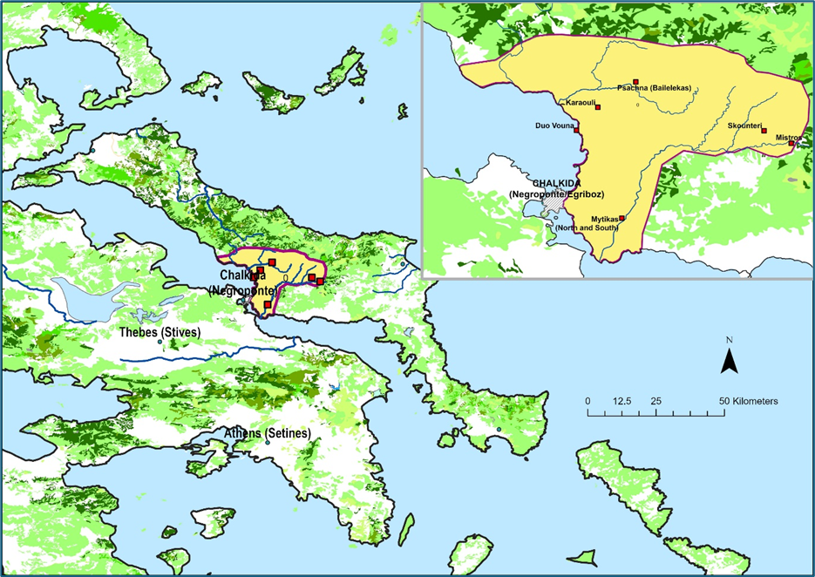
Figure 1: Map of Central Greece with Survey area and towers sampled (inset)
More than two hundred towers of various designs once existed in Central Greece. Most are thought to have been built by forces of the Fourth Crusade (Frankish and Italian), following their capture of Constantinople, immediately after their annexation of the region in late 1204. Their construction has therefore been seen as a process of colonisation by the minor nobility (the knights) to display their power and control their fiefs and Greek subjects. Yet none has ever been scientifically dated.

Tower Name | GPS co-ordinates
Mistros | 38.31.248, 023.50.592
Skounteri | 38.32.040, 023.48.921
Psachna (Bailelekas) | 38.35.023, 023.41.072
Karaouli | 38.33.466, 023.38.740
Duo Bouna | 38.32.054, 023.37.429
Mytikas (North) | 38.26.698, 023.40.283
Mytikas (South) | 38.26.654, 023.40.235
Table 1. Tower names and GPS co-ordinates

Sampling process
Members of the survey team together with specialised scaffolders, supervised by technical staff from the Institute of Nanoscience and Nanotechnology ‘Demokritos’ in Athens and from the Ephorate of Antiquities in Chalkida, obtained samples in October 2022 from the seven towers detailed in table 1 (Figure 1). All of the towers were in an advanced stage of collapse and samples were taken of the wood used to provide internal lateral structural integrity to their walls. This ensured that the wood was not part of a subsequent repair or renovation, which would have been the case for beams used to support the multiple floors of the towers, but part of the original construction phase.
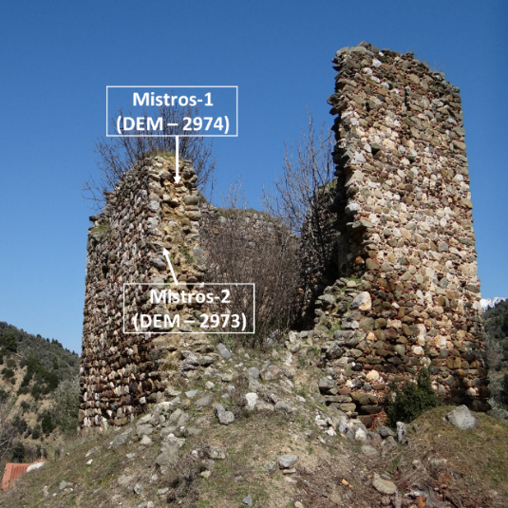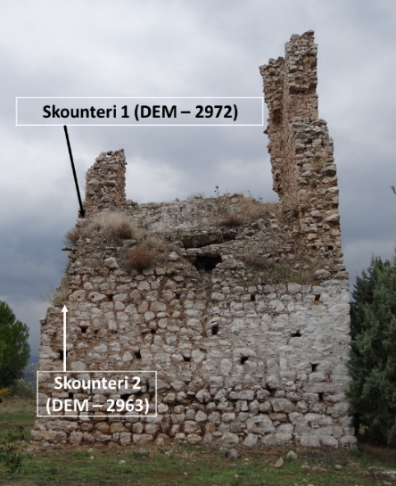
- Mistros tower (b) Skounteri tower
Figure 2. Examples of two towers indicating sampling points
At the same time samples were also taken from various points of mortar used to bind the rough stonework from which the towers had been constructed. Again, our aim was to avoid results being compromised by later external rendering or repointing of the walls. Wherever possible, sampling points (for both wood and mortar) were at different heights, in order to understand if construction had been undertaken in phases - something that subsequently became very important for two towers. The samples were then sealed and despatched to the laboratory for processing and analysis.

The Report on wood beam dating
The final laboratory report was issued from the Institute of Nanoscience and Nanotechnology ‘Demokritos’ on 20th May 2024 by Dr Giorgos Polymeris and Dr Yiannis Maniatis. For each sample the outermost rings were dated. However, sawing by the ancient builders and erosion meant that some outermost rings (those immediately below the bark) were missing. In order to best approximate ‘the date of fell’ an estimate had to be made of these based on the thickness and density of the rings in each beam, the curvature of the rings and the radius and shape of the beam. With some reservations, since this is outside the team’s research area, it is thought that five samples (Mytikas (north) 1 &2, Skounteri-1, Psachna-2, and Skounteri-2) are oak.
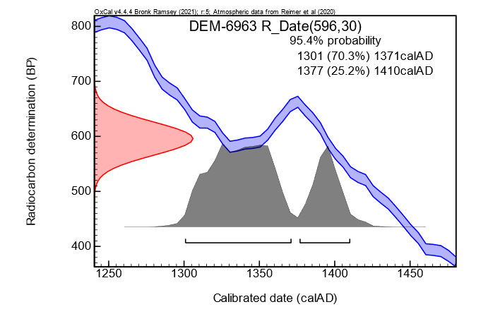
Figure 2. An example of calibration showing the wiggle in the calibration curve that
causes widening of the calibrated ages and splitting of the ranges.

All ten wood samples were dated using radiocarbon dating methodology with over 95% confidence to the period from 1270 to 1434. One tower (Mistros) was dated to approximately 1300 (+/- 30 years), but the dating of the rest suffered from a basic technical problem. During the fourteenth century there were fluctuations in the cosmic concentration of ¹⁴C in the earth’s atmosphere caused by solar activity: there were therefore two possible dating ranges identified, thus reducing accuracy to approximately +/- fifty years. This effect is demonstrated in figure 2 where radiocarbon age determination (red) for one sample is plotted against calibrated date (grey) and a plot of the fluctuating atmospheric ¹⁴C concentration (blue).

Laboratory Code | Sample | Age ¹⁴C (ΒΡ) | δ13C (‰) | Calibrated date (AD) | Tree rings dated | Estimated rings until bark | Estimated date of fell (AD) | Probab. (95.4%)
DEM – 2972 | Skounteri-1 | 630 ± 30 | -24.66 | 1293 – 1398 | 13 – 23 | 13 | 1305 – 1411 | (95.4%)
DEM – 2963 | Skounteri-2 | 596 ± 30 | -24.35 | 1301 – 1371  1377 – 1410 | 57 – 69 | 19 | 1320 – 1390  1397 – 1429 | (70.5%)  (25.0%)
 | (wiggle analysis) |  |  |  |  |  | 1396-1418 | (95.4%)
DEM – 2965 | Psachna-1 | 691 ± 30 | -22.71 | 1272 – 1317  1360 – 1389 | 5 – 11 | 15 | 1285 – 1333  1374 – 1404 | (66.5%)  (28.9%)
DEM – 2964 | Psachna-2 | 677 ± 30 | -25.51 | 1276 – 1321  1358 – 1390 | 33 – 42 | 17 | 1292 – 1337  1374 – 1407 | (57.0%)  (38.4%)
DEM – 2967 | Mytikas South-1 | 594 ± 30 | -25.45 | 1301 – 1370  1378 – 1411 | 8 – 15 | 19 | 1320 – 1388  1397 – 1429 | (70.1%)  (25.4%)
DEM – 2966 | Mytikas North-1 | 614 ± 30 | -24.26 | 1299 – 1401 | 24 - 33 | 15 | 1314 – 1416 | (95.4%)
DEM – 2969 | Mytikas North-2 | 623 ± 30 | -24.93 | 1295 – 1400 | 43 – 72 | 35 | 1330 – 1434 | (95.4%)
 | (wiggle analysis) |  |  |  |  |  | 1334-1374 | (95.4%)
DEM – 2970 | Karaouli-1 | 670 ± 30 | -23.89 | 1277 – 1323  1357 – 1392 | 20 – 29 | 14 | 1288 – 1337  1367 – 1406 | (52.9%)  (42.6%)
DEM - 2974 | Mistros-1 | 776 ± 30 | -24.88 | 1220 – 1281 | 32 - 45 | 50 | 1270 – 1331 | (95.4%)
DEM – 2973 | Mistros-2 | 697 ± 30 | -24.75 | 1269 – 1314  1361 – 1388 | 28 - 44 | 13 | 1281 – 1328  1373 – 1401 | (70.9%)  (24.6%)
Table 2. Listing of results for each sample

Following discussion, the laboratory was requested to undertake what is called a ‘wiggle analysis’ to try to improve dating accuracy for certain samples, where the quality of the wood sample allowed. This process involves dating four or five batches of tree ring samples in sequence. Unfortunately, this was only possible for two – Skounteri-2 and Mytikas(North)-2 – which resulted in a weighted mean dating of 1407 and 1353 respectively.

Mortar Sampling Results
In total 18 (eighteen) mortar samples were examined. They were subjected to a number of different analyses using optical microscopy and scanning electron microscopy (SEM), handheld portable X-ray fluorescence analysis (pXRF), and X-ray diffraction spectroscopy (XRD).

Sample code | Tower Name | CaO | MgO
BM1 | Mytikas (north) -upper | 78.57 | 2.77
BM2 | Mytikas (north) - lower | 59.52 | 20.91
BM3 | Mytikas (north) - upper | 89.15 | 2.11
BM4 | Mytikas (north) - lower | 70.63 | 14.47
NM1 | Mytikas (south) | 81.59 | 3.32
NM2 | Mytikas (south) | 68.19 | 7.88
NM3 | Mytikas (south) | U/A | U/A
K1 | Karaouli | 93.73 | 1.58
K2 | Karaouli | 90.56 | 1.43
K3 | Karaouli | 89.62 | 1.42
DB1 | DuoBouna | 95.04 | -
DB2 | DuoBouna | 93.97 | 1.55
DB3 | DuoBouna | 95.52 | 1.27
B1 | Psachna (Bailelekas) | 96.12 | -
B2 | Psachna (Bailelekas) | 98.65 | -
B3 | Psachna (Bailelekas) | 95.8 | -
B4 | Psachna (Bailelekas) | 95.56 | 0.94
B5 | Psachna (Bailelekas) | 88.23 | 1.59
Table 3. Listing of mortar samples with percentage of key components
Analysis of the mortar samples shows that all contain predominantly Calcite, Grossular, Grossite and Sodium Aluminosilicate Hydrate. Most also contain magnesium (Mg) in the Calcite. In this way we can separate the construction of two towers into two stages (see figure 3): the Mytikas (north) tower, since there are low traces of magnesium in its bottom section mortar (samples BM2,BM4) while much higher levels are present in the upper sections (samples BM1,BM3); and the Psachna (Bailelekas) tower, where not only is magnesium not present in the upper level mortar (samples B1,B2,B3) whilst there is a small percentage in the lower level (samples B4,B5), but also the level of iron and sand(Quartz) is less in these samples than those from the lower level (Figure 3).
The evidence also suggests that the chemical composition of the mortar of three towers (Psachna(Bailelekas), Karaouli and DuoBouna) is similar - an important finding since it may indicate that the construction of the DuoBouna tower, where we have no wood beam samples to date, may be within a similar time period to the first two towers ie. the early 14th century. Further evidence is, however, required to confirm this. Finally, the chemical composition of the mortar from the two Mytikas towers is also analogous.

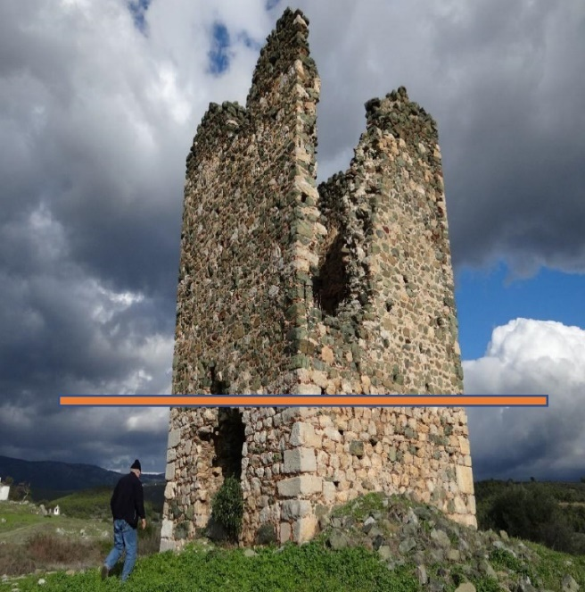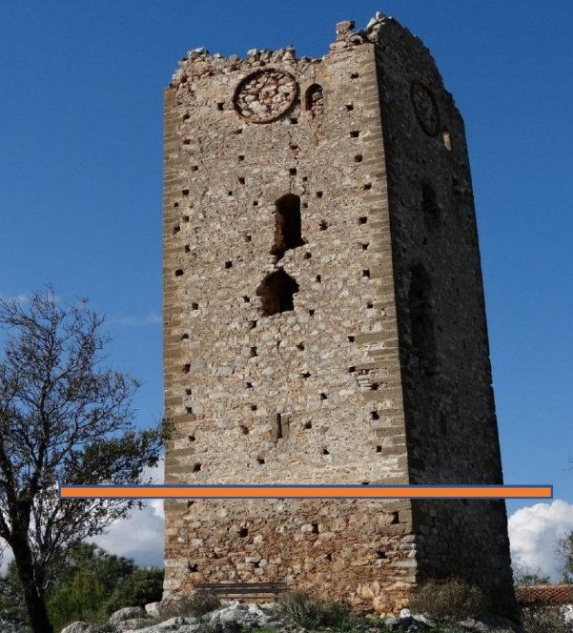
- Psachna (Bailelekas) tower (b) Mytikas (north) tower
Figure 3. Different technological construction phases
Costs
The basic costs involved - those of the laboratory analysis of the wood and mortar samples – were supported by the Castle Studies Trust. Other costs such as preparatory survey work, the scaffolding team, transport etc have been funded by the author.

Existing Literature
The towers of Central Greece were first published in the English language literature by Peter Lock in a series of articles between1987 and 1996, with John Langdon providing a supplement for those around Athens in 1995. The former’s article on the towers of Euboea was based on that of a local researcher, Theodoros Skouras (1975), work which he updated in 2003, and has been included in a site gazetteer in the unpublished PhD thesis of Andrew Blackler (2020). Although all authors were very hesitant to date the towers – Langdon referred simply to ‘mortared’ towers – others have been more forthright. Such writers have considered the towers to be a feudal construct following the region’s annexation post-1204 and a product of its colonisation by western Latin forces, yet without any scientific evidence (e.g. Loizou, 2016).
Only two towers in the wider region – these in the area of Boeotia – have been dated with any accuracy. The first may be termed an elite tower in that its size and quality of construction far surpasses any other surviving towers. It now forms part of the archaeological museum at Thebes. This tower was constructed by Nicholas II of St Omer, lord of half of Thebes from 1258 until his death in 1294 and is the only remains of the major fortress that once existed there. The other, Panakton, is situated close to the mountain road midway between Athens and Thebes. It was excavated by Gerstel et al. in 1991-92: based on ceramic evidence from the settlement below it may be provisionally dated within a century commencing in the early 1300s.

Implications and Discussion
The present study reinforces, therefore, this dating. By placing tower construction (except for that at Mistros) firmly in the fourteenth century it clearly precludes towers being built immediately following the annexation of the region by Latin forces post 1204: a hundred years and five generations separate the two dates. Mistros, the only tower in the present study which has a dating possibly in the late thirteenth century, appears to have performed a clear military role – from the configuration of its window slits it has been shown to have been used as a watchtower, from which to observe beacons, as part of a long-distance communication system (Blackler, 2022).
By looking at the historical context we can understand the role that towers may have played within central Greece in this late-medieval period. From 1204, when a corrupt Byzantine administration was relatively peaceably superceded by that of the incoming Latins, there was generally harmony in the region for fifty years. In 1255 civil war, lasting nearly five years, broke out between the prince of Achaia based in the Peloponnese and the lords of Athens and Euboea. Shortly after, a resurgent Byzantine state, having recaptured Constantinople in 1261, began attacking Central Greece and invaded Euboea in the late 1270s.
From then until about 1295 the island was continuously at war and all the major fortresses were refortified. Within such a scenario, estate owners at a distance from a safe haven needed to protect themselves and their tenants, and the tower was the perfect solution! Unlike in the west, or in the Kingdom of Jerusalem in the 12th century, the crusaders do not appear to have constructed massive donjons immediately on their arrival. Rather, as a military drawing from the seventeenth century suggests, they had constructed large halls as their estate centres and only added a tower when the security situation deteriorated.
In 1311, things worsened even further. A group of Catalan mercenaries revolted against their employer, the Duke of Athens, Walter of Brienne, and on the muddy battlefield at Halmyros in Boeotia on the mainland the massed cavalry of the lords of the region were decimated by an army of foot soldiers, a battle reminiscent of that of Crecy in 1346. The Catalans took over all of mainland central Greece. In order to consolidate their position they probably constructed towers to protect themselves against a hostile local populous. Such a rationale would support the early 14th century dating of the Panakton tower (see above). The Catalans also had first-hand experience of similar towers in northern Greece as they first fought for and then revolted against the Byzantine emperor, their previous paymaster.

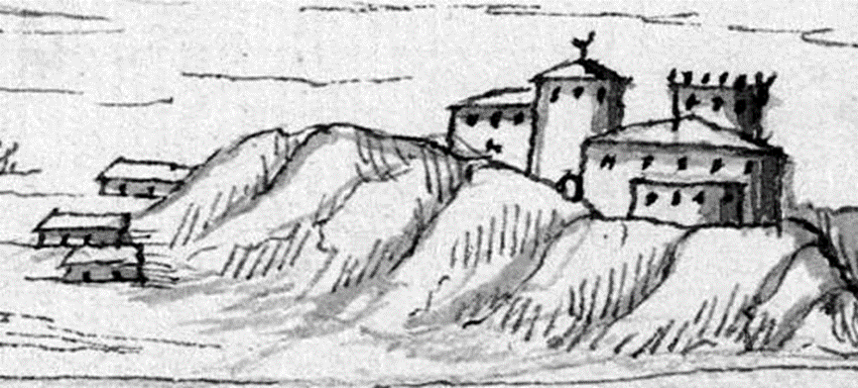
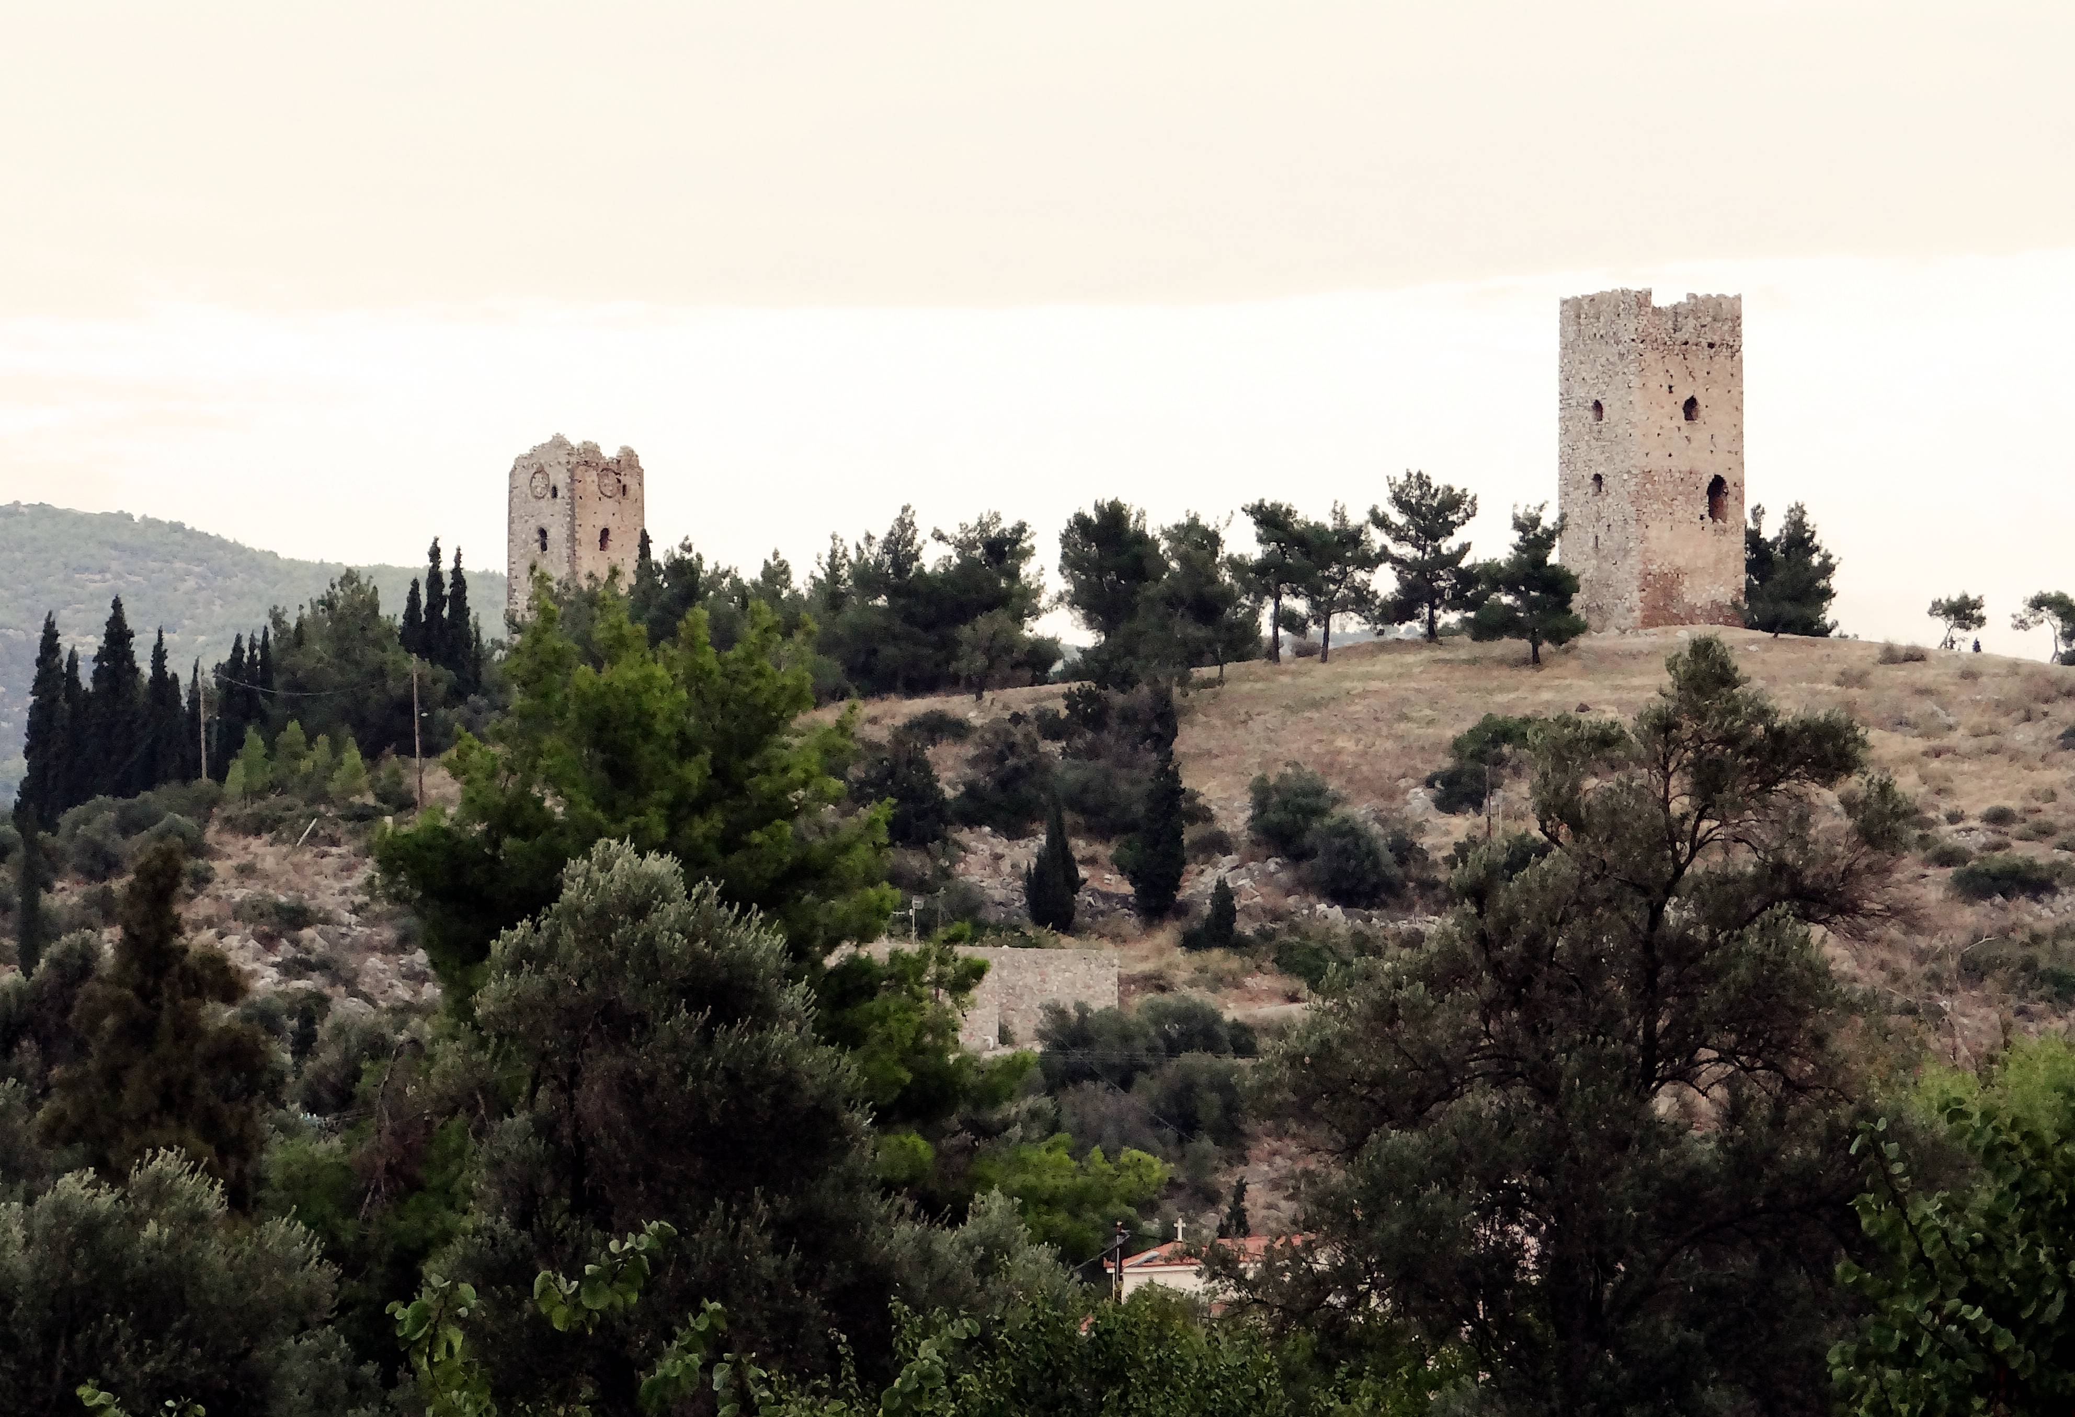
Figure 2: The Twin towers in Mytikas – sketch (c.1660), photograph (2022)

In 1317, they invaded Euboea. After controlling the island for two years except its capital, which was reinforced and supplied from the sea by Venetian naval forces, they withdrew, maintaining control only of the southern region. For the next twenty years until the Euboean lords (supported by the Venetians) came to an accommodation with the Catalans there was almost continuous conflict, made worse by a growing number of attacks by Turkish corsairs from the sea. Judging from their 14th century dating most of the towers of Euboea are probably a product of this period of insecurity as small bands of mounted knights by land or corsairs by sea terrorised local settlements. Their construction, contrary to present literature – whether on the mainland or Euboea - does not appear therefore to have been part of a ‘colonial’ process in the early 13th century.
This also has a further implication. The Crusader annexation of Euboea in the autumn of 1204 was almost bloodless. The Latin forces were fighting not against Byzantine imperial troops but those of the local warlord Sgouros, based in Corinth, who had effectively usurped power as the central Byzantine administration weakened in the latter years of the twelfth century. Should we be looking at the period after 1204 on Euboea (if not in central Greece) not so much as a conquest but a realignment of loyalties as local archontes looked to replace a corrupt ineffective Byzantine administration with the apparent military strength and economic opportunities that the Latins presented?

Publication of Results
A. Blackler, (June 2023) ‘The medieval Towers of Central Greece’, Castle Studies Present and Future: Castle Studies Trust conference.
A. Blackler, (Sept. 2023) ‘The Defence of Euboea’, Paper at the first public lecture in the new Chalkida branch of the Greek National War Museum.
A. Blackler and M. Panagopoulouy (Aug. 2024), ‘Wood and mortar sampling of medieval towers in Central Greece’, 30th Annual Meeting of the European Association of Archaeologists in Rome (paper proposal accepted)
A. Blackler, M. Panagopoulou et al. Wood and mortar sampling of medieval towers in Central Greece, Journal of Anthropological and Archaeological Sciences (awaiting acceptance of article proposal – this will include full descriptions of analysis techniques and scientific processes)
J. Vroom et al. ‘Annual report of the Hinterland of medieval Chalkida, 2024’ Pharos – journal of the Netherlands Institute at Athens (expected publication 2025/2026)

Dr Andrew Blackler
Wood Analysis - Dr Giorgos Polymeris and Dr Yiannis Maniatis
Mortar Analysis – Dr Adamantia Panagopoulou and Dr Anno Hein
25 May 2024

References

BINTLIFF, J. 2012. The Complete Archaeology of Greece, from Hunter-Gatherers to the 20th Century A.D., Chichester, Wiley-Blackwell.
BLACKLER, A. 2022. Communication and the Role of the Medieval Tower in Greece: a Re-appraisal. Annual of the British School at Athens, 117, 393-414.
GEORGOPOULOU, M. 2014. The Landscape of medieval Greece. In: TSANGARAKIS, N. & LOCK, P. (eds.) A Companion to Latin Greece. Leiden: Brill, 327-368.
LANGDON, M. K. 1995. The Mortared Towers of Central Greece: An Attic Supplement. The Annual of the British School at Athens, 90, 475-503.
LOCK, P. 1986. The Frankish Towers of Central Greece. The Annual of the British School at Athens, 81, 101-123.
LOCK, P. 1989. The medieval towers of Greece: A problem in chronology and function. In: ARBEL, B., HAMILTON, B. & JACOBY, D. (eds.) Special Issue: Latins and Greeks in the Eastern Mediterranean After 1204. Mediterranean Historical Review, 4(1), 129-45.
LOCK, P. 1996. The Towers of Euboea: Lombard or Venetian, agrarian or strategic. In: LOCK, P. & SANDERS, G. D. R. (eds.) The archaeology of medieval Greece. Oxford, 107-126.
LOIZOU, C. 2016. The medieval towers in the landscape of Euboea: landmarks of feudalism. Journal of Greek Archaeology, 1, 331-352.

